**SUPERSET ID: 6372353 NAME : VARUN S**

**Exercise 1: Control Structures**

**Scenario 1:** The bank wants to apply a discount to loan interest rates for customers above 60 years old.

* + **Question:** Write a PL/SQL block that loops through all customers, checks their age, and if they are above 60, apply a 1% discount to their current loan interest rates.

**ANSWER:-**

**Create the customers and loans Tables**

**Insert Sample Data**

**Apply 1% Discount for Age > 60**

**Output**

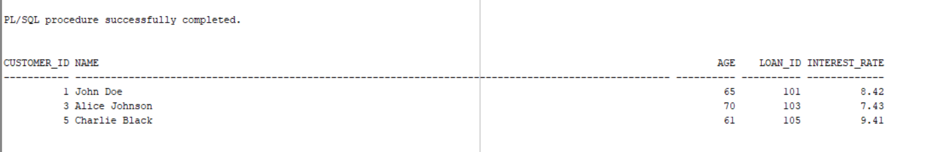

**Folder Structure**

**Scenario 2: A customer can be promoted to VIP status based on their balance.**

* + Question: Write a PL/SQL block that iterates through all customers and sets a flag IsVIP to TRUE for those with a balance over $10,000.

**ANSWER:-**

**Create the customers and loans Tables**

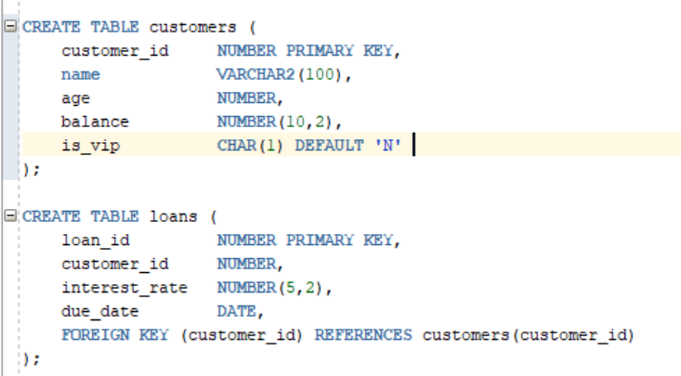

**Insert Sample Data**

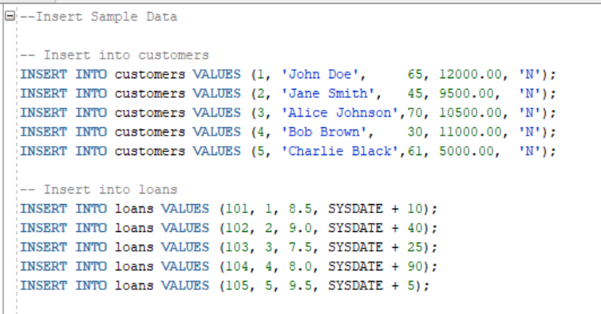

**Promote customers to VIP status if their balance is over $10,000.**

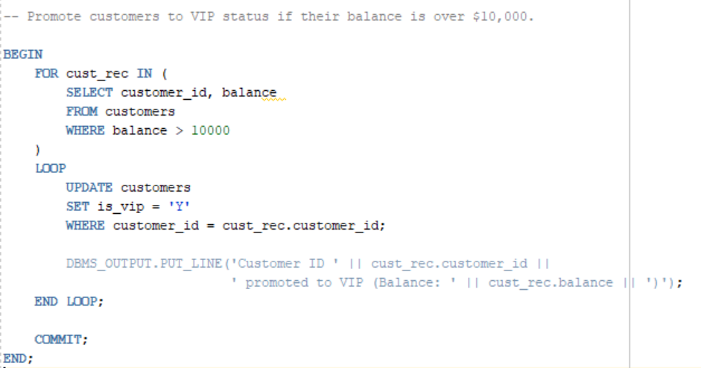

**Output**

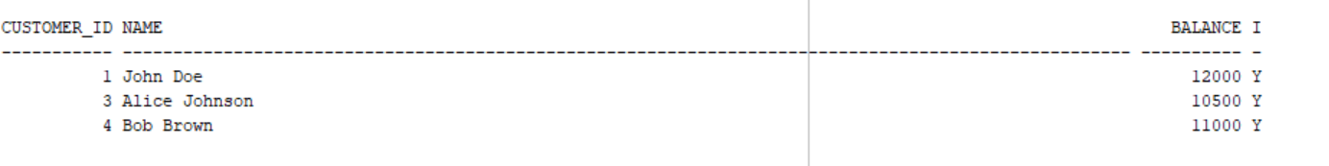

**Folder Structure**

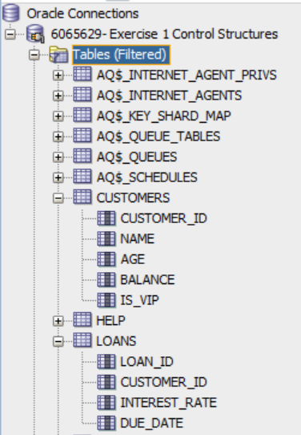

**Scenario 3: The bank wants to send reminders to customers whose loans are due within the next 30 days.**

* + Question: Write a PL/SQL block that fetches all loans due in the next 30 days and prints a reminder message for each customer.

**Create the customers and loans Tables**



**Insert Sample Data**

**Fetch loans due within the next 30 days and print reminder messages to the customers.**

**Output**

**Folder Structure**

